**JUnit5 Basic testing Exercises**

**Exercise 1: Setting up Junit**

**Code:**

<dependency>  
 <groupId>junit</groupId>  
 <artifactId>junit</artifactId>  
 <version>4.13.2</version>  
 <scope>test</scope>  
</dependency>

**Exercise 3: Assertions in JUnit**

**Code:**

public class AssertionsTest {  
 @Test  
 public void testAssertions() {  
 Assertions.*assertEquals*(5, 2 + 3);  
 Assertions.*assertTrue*(5>3);  
 Assertions.*assertFalse*(5<3);  
 Assertions.*assertNull*(null);  
 Assertions.*assertNotNull*(new Object());  
 }  
}

**Output:**

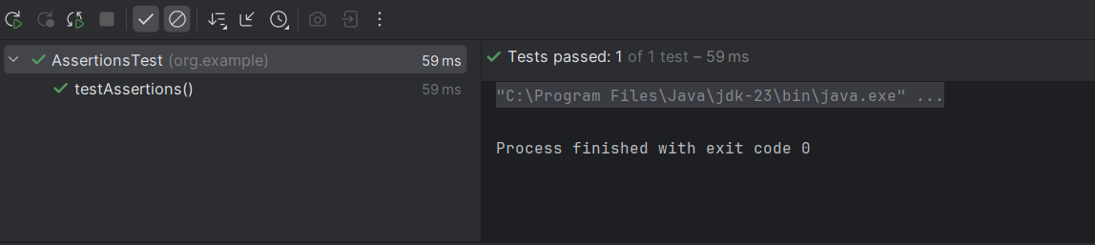

**Exercise 4: Arrange-Act-Assert (AAA) Pattern, Test Fixtures, Setup and Teardown Methods in Junit**

**Code:**

public class AAATest {  
  
 @Before  
 public void setUp() {  
 System.*out*.println("Before each test: setup()");  
 }  
  
 @After  
 public void tearDown() {  
 System.*out*.println("After each test: tearDown()");  
 }  
  
 @Test  
 public void AAA() {  
 //Arrange  
 int a = 3;  
 int b = 4;  
 int expectedSum = 7;  
  
 int greater = 5;  
 int smaller = 3;  
  
 Object nullObject = null;  
 Object nonNullObject = new Object();  
  
 //Act  
 int actualSum = a + b;  
 boolean isGreater = greater > smaller;  
 boolean isSmaller = greater < smaller;  
  
 //Arrange  
 Assertions.*assertEquals*(expectedSum, actualSum);  
 Assertions.*assertTrue*(isGreater);  
 Assertions.*assertFalse*(isSmaller);  
 Assertions.*assertNull*(nullObject);  
 Assertions.*assertNotNull*(nonNullObject);  
 }  
}

**Output:**

